Cheddar muffins

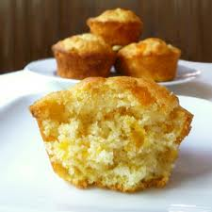
Ingredients

Serves: 12
- 250g plain flour
- 3 1/2 teaspoons baking powder
- 1 teaspoon salt
- 1 teaspoon paprika
- 50g butter
- 1 egg
- 250ml milk
- 120g grated Cheddar cheese
- 100g sultanas or raisins

Method

Prep:15min › Cook:25min › Ready in:40min
- Sift flour with baking powder, salt and paprika. Rub in butter finely. Stir in remaining ingredients just until dry ingredients are moistened.
- Spoon into well-greased muffin tins. Bake in a preheated 220 C / Gas mark 7 oven for 25 minutes.

