Classic Strawberry Ice Cream

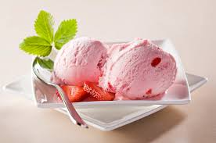
Ingredients

Serves: 32
- 2 (405g) tins sweetened condensed milk
- 1.2L (2 pints) milk
- 475ml (16 fl oz) double cream
- 2 tablespoons vanilla essence
- 1/2 teaspoon salt
- 500g (1 1/4 lb) strawberries, hulled and chopped

Method

Prep:45min › Ready in:45min
- Combine all ingredients in freezer canister of ice cream maker. Freeze according to manufacturer's directions.

