Pomegranate Smoothie
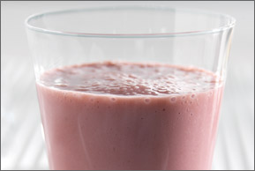
Makes 4Servings
Prep Time: 5min
Cook Time: 3min
Ingredients
1 banana
2 cups (16 ounces) fat-free vanilla yogurt
1 cup pomegranate juice
1 tablespoon coarse sugar (optional)
pomegranate seeds (optional)
Wrap peeled banana in plastic wrap and freeze 3 hours or until frozen.
Unwrap banana, break into chunks and place in a blender with the yogurt and juice. Cover and blend until smooth; pour into 4 glasses to serve. Top with pomegranate seeds if desired.
Serving tip: Before serving, wet edge of glass and dip into coarse sugar for decorative edge.
Recipe created by 3-Every-Day™ of Dairy
Nutritional Facts
Calories: 170
Total Fat: 0 g
Saturated Fat: 0 g
Cholesterol: 0 mg
Sodium: 85 mg
Calcium: 20% Daily Value
Protein: 6 g
Carbohydrates: 36 g
Dietary Fiber: 1 g
- See more at: http://www.nationaldairycouncil.org/Recipes/Pages/Pomegranate-Smoothie.aspx#sthash.0dfjOAlV.dpuf

