Raspberry chocolate fudge

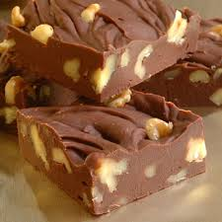
Ingredients

Serves: 40
- 500g good quality dark chocolate
- 1 (400g) tin sweetened condensed milk
- 1 1/2 teaspoons vanilla extract
- salt to taste
- 60ml double cream
- 60ml raspberry liqueur
- 350g good quality dark chocolate

Method

Prep:10min › Cook:10min › Ready in:20min
- Grease a 23cm (9 in) square baking tin and line with greaseproof paper.
- In a microwave-safe bowl, combine 500g chocolate and sweetened condensed milk. Heat in microwave until chocolate melts, stirring occasionally. Stir in vanilla and salt. Spread into tin and cool to room temperature.
- In a microwave-safe bowl, combine cream, raspberry liqueur and 350g dark chocolate. Heat in microwave until the chocolate melts; stir until smooth. Cool to lukewarm then pour over the fudge layer. Refrigerate until both layers are completely set, about 1 hour. Cut into 40 squares.

