Simple no fuss bread and butter pudding

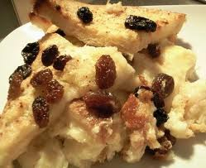
Ingredients

Serves: 7
- 100g sugar
- 1 teaspoon ground cinnamon
- 5 slices of any bread
- Butter
- 3 handfuls sultanas
- 500ml milk
- 2 eggs

Method

Prep:10min › Cook:30min › Extra time:5min resting › Ready in:45min
- Preheat oven to 190 C / Gas mark 5. Lightly grease a baking dish.
- Mix together the sugar and cinnamon.
- Butter 5 slices of bread, cut in half.
- Layer the bread in the dish adding a handful of sultanas and the sugar mix as you go, covering each slice.
- Mix the milk and eggs together and whisk.
- Pour over the bread and leave to absorb for 10 minutes.
- Bake in the oven for 35 to 45 minutes, until the pudding is set and browned.

