Strawberry Frozen Yogurt Squares
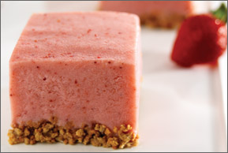
Makes 9Servings
Prep Time: 10min
Cook Time: 180min
Ingredients
1 cup crunchy wheat and barley cereal
3 cups fat-free strawberry yogurt
1 (10-ounce) bag frozen unsweetened strawberries (about 2 1/2 cups)
1 cup fat-free sweetened condensed milk
1 cup light or fat-free whipped topping (optional)
Line an 8x8-inch baking pan with foil. Sprinkle cereal evenly on the bottom of the pan; set aside.
Place yogurt, strawberries and condensed milk in a blender; cover and blend until smooth. Pour the mixture over top of cereal, gently smoothing yogurt mixture to edges of pan. Cover with foil (or plastic wrap) and freeze for 8 hours or until firm. Use edges of foil to loosen and remove from pan; let recipe thaw for 5 to 10 minutes. Cut into squares, top with whipped topping, if desired, and serve.
Storage tip: Squares may be individually wrapped and frozen for single servings.
Note: Create your own variations by using other flavor combinations of yogurt and fruit.
Recipe created by 3-Every-Day™ of Dairy
Nutritional Facts
Calories: 200
Total Fat: 0 g
Saturated Fat: 0 g
Cholesterol: 5 mg
Sodium: 150 mg
Calcium: 20% Daily Value
Protein: 7 g
Carbohydrates: 42 g
Dietary Fiber: 2 g
- See more at: http://www.nationaldairycouncil.org/Recipes/Pages/Strawberry-Frozen-Yogurt-Squares.aspx#sthash.MCpqCPR4.dpuf

